### **Analyzing 311 Responses**

Ivan Niktitovic, Stephen Wong, Haoxuan Sun

[in@bu.edu](mailto:in@bu.edu), [swluquez@bu.edu](mailto:swluquez@bu.edu), [hs4379@bu.edu](mailto:hs4379@bu.edu)

May 3, 2023

**Introduction (Worked by Stephen)**

With the collaboration of the Boston City Council and Councilor Mejía, the “Analyzing 311 Calls” project deals with helping understand relationships between 311 callers and their correlation with the events that happen in the community. For this project, we are studying more specifically how people more likely to do 311 calls are correlated with leaders in the community who are more likely to have active voices in the community and feel empowerment. We also want to see the effectiveness of how these 311 calls are answered, whether they are serviced in a responsible time frame or if they are not solved at all. We use data from the main areas in Boston to check where there is an increase in calls, where people are most likely to vote and other factors that may affect the community. Our goal for this project is to help Councilor Mejía by providing information that can be useful to combat problems in the community by allocating resources towards areas with more need for response and also provide a correlation between empowerment, voting status and making 311 calls.

**Base Analysis (Worked by Stephen, Ivan)**

For the analysis, we first worked on combining all of the data together. We used the datasets for 311 calls from 2010 to 2022 to conduct our analysis. We also pulled information from census data, vulnerability status information, and voting turnout to answer some of the other questions assigned to our team. This information wasn’t always one to one with the other so a considerate cleaning was done.

Our first question was:

1. Analyze which neighborhood submitted the most service requests?

Referring to Table 1, The data we pulled classified different populations within an area as different hence there is repetition on our top 10 most calls per population and doesn’t refer to the whole area needing help but more of a subset. This information paired with the cluster from Table 2, shows that these areas in the top 10, over the past 10 years or so have been needing the most response to 311 calls. We also did a linear regression which showed that there was a weak negative relationship found between the number of 311 calls and the Social Vulnerability Index. This result hints towards the idea that the more empowered a community is, the more likely they are to call 311.

For our second question we studied:

1. What is the relationship between voting status (i.e. registered voters and and civic empowerment? What is the average voting turnout for each district over past XX years?

For this question we paired different elections with social vulnerability index and the voting turnout for the last 5 election years to see the vulnerability index of the areas who voted during each election. In Table 3 we have an example of the turnout for 2002 in which we can observe that in most census tracts there were around 40 to 80 percent voting and we see that it was mostly from people on the 0.2 to 0.6 on the vulnerability index. This shows that people on either end of the vulnerability index scale are either less likely to vote or that most people in an area are found somewhere in the middle of the scale. In Table 6 we did a linear regression in which we can see that the higher the population in the social vulnerability index, the less likely the turnout. Our conclusion for this question was that there was a strong negative relationship found between voting turnout and SV Index. The more vulnerable a community is, the less likely they are to vote.

In Table 4, we have an example of 5 areas in Boston and vulnerability index compared to the voting turnout on each election as well as the amount of 311 calls per area. We can check here again our study from the previous question in which Social Vulnerability is linked to calls and we get to see what percentage of the votes this subset area did for the general area.

For our third question we studied:

1. What is the relationship between voting status (i.e. registered voters and and city responsiveness in terms of closing 311 requests? What is the average voting turnout for each census tract over the past 20 years?

For this question, similarly to the previous one, we take voting status again but compare it to its relationship with the closing of the 311 requests. As we can see in Table 6, we see there isn’t really a clear correlation between the two. We see that most calls take around 20-25 days to get serviced and also that election turnout ranges more between 30 to 50 percent.

**Extension Analysis - Property Violations (Worked by Haoxuan and Ivan)**

For the extension part of the project, we raised a proposal on analyzing the relationship between building/property violations and 311 requests using a Boston government dataset. With this idea, we could find areas where building violations are more frequent, therefore being able to set more specific resources towards those areas. This would be more specialized resources rather than easier requests such as graffiti and trash removal.

There are two reasons why the team chose this extension idea. Firstly, building and property violations impact public safety and quality of life. By identifying contributing factors, the team hopes to aid in developing effective prevention and addressing strategies. Also, 311 requests provide insight into residents' concerns and priorities. Analyzing their relationship to building violations can inform policy decisions and improve Bostonians' lives.

Three questions have been analyzed:

1. Is there a pattern between neighborhoods with more property violations and 311 requests made?

According to our research, we found there to be a strong correlation. It is shown on the heatmaps in Table 7 where we can observe the number of property violation records since 2009 (left) and the 311 calls from 2010-2023 (right) on the Boston neighborhood map . It is obvious that the neighborhoods with more property violations tend to have more 311 calls, which is reasonable.

1. What areas have the most property violations?

The bar chart in Table 9 and pie chart in Table 8 indicate that Dorchester has the highest number of violations compared to other neighborhoods, accounting for approximately 28% of all violations. East Boston and Roxbury follow as the second and third highest neighborhoods in terms of violations. Together, these three neighborhoods account for almost half of all violations.

By looking at the violations that happened in only Dorchester and group by zip code (Table 10), we can find out that the area with zip code “02124” had most violations and accounts for nearly a third of all property violations in Dorchester and in Table 11 we can observe how they are divided.

1. Is there a correlation between the number of 311 calls and the number of property violations per census tract?

In reference to Table 12, a significant positive correlation is observed between the volume of 311 calls and the instances of property violations within a given census tract. This suggests that as the number of property violations increases, there is a corresponding rise in 311 calls. The analysis presented in the table highlights the strong connection between these two variables, which is crucial for understanding the relationship between public complaints and property code infractions in the studied area.

According to the data presented in Table 13, it can be observed that there exists a marginally negative correlation between the Social Vulnerability Index values and the total number of 311 calls made. This relationship implies that as the Social Vulnerability Index increases, there is a slight decrease in the volume of 311 calls.

**References**

Boston Maps Analytics Team. “CENSUS 2010 TRACTS.” *Analyze Boston*, Boston Maps, 4 Apr. 2019, https://data.boston.gov/dataset/census-2010-tracts.

“BUILDING AND PROPERTY VIOLATIONS.” Edited by Inspectional Services Department, *Analyze Boston*, Department of Innovation and Technology, 2023, https://data.boston.gov/dataset/building-and-property-violations1.

“CLIMATE READY BOSTON SOCIAL VULNERABILITY.” Translated by Atyia Martin, *Analyze Boston*, Boston Government, 2015, https://data.boston.gov/dataset/climate-ready-boston-social-vulnerability.

O'Brien. “311 Requests Database.” *Harvard Dataverse*, Harvard, 7 Oct. 2022, https://dataverse.harvard.edu/dataset.xhtml?persistentId=doi:10.7910/DVN/CVKM87.

Voong, Michelle, editor. “Voter File MA.” *Boston Voting File*, 2020, https://drive.google.com/drive/folders/1DyCevtTWTMMNrZXsCycLGiSA_uc6lq8r.

**Appendix (Worked by Stephen, Ivan, Haoxuan)**

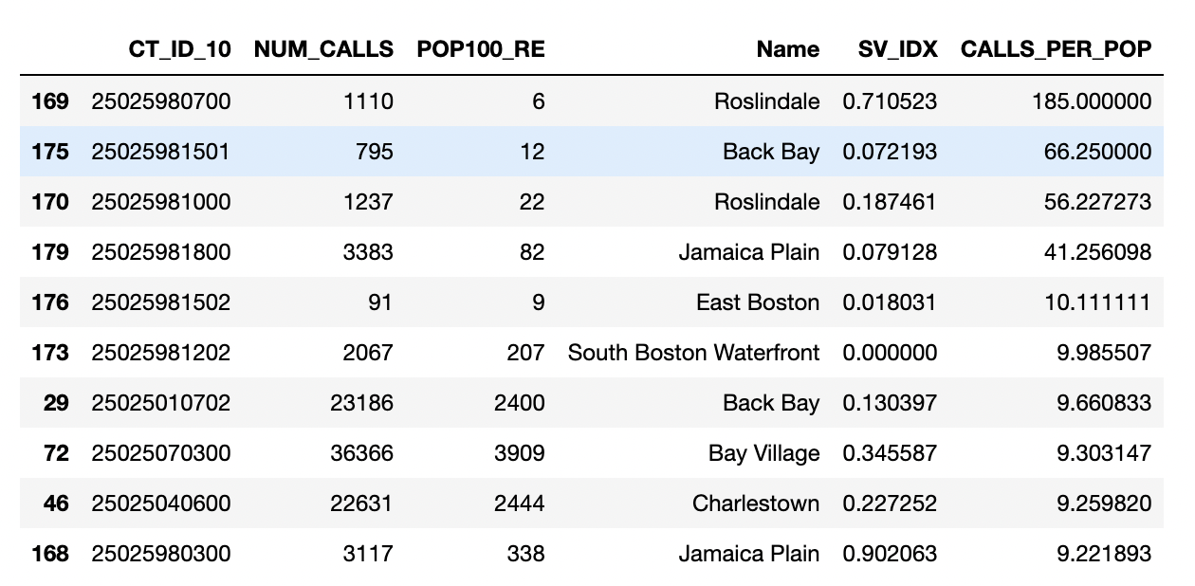

Table 1: Table showing areas with the most 311 requests

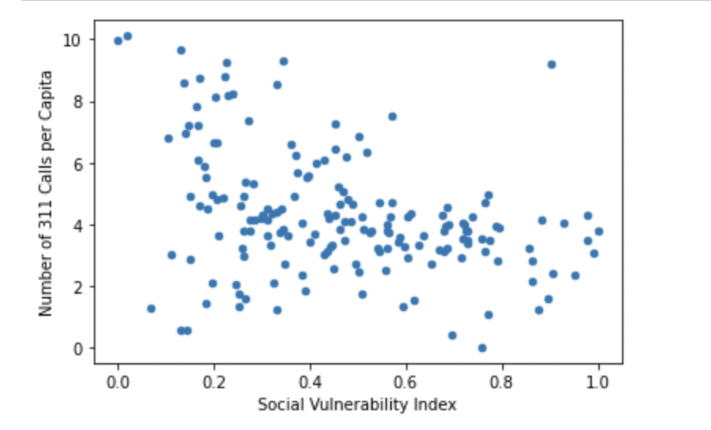

Table 2: Scatter plot of the social vulnerability index given the number of 311 calls per group

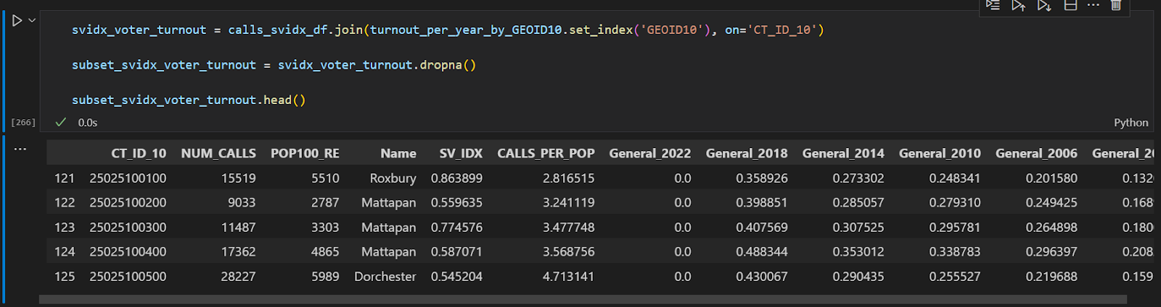

Table 3: Table showing information about voter participation per area

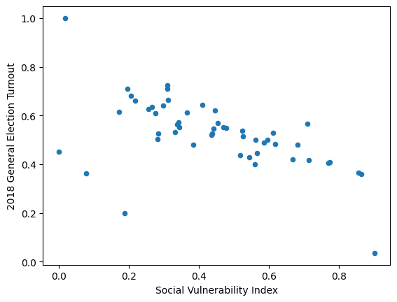

Table 4: Sample of the 2018 election turnout related to the social vulnerability index

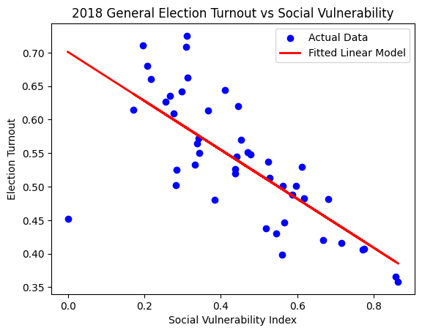

Table 5: Linear regression of turnout and social vulnerability index

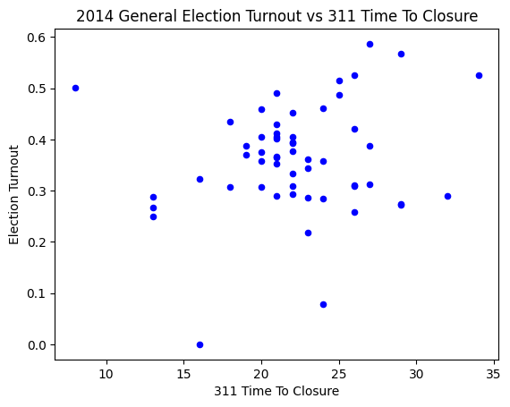

Table 6: Scatter plot of 311 response times and election turnout

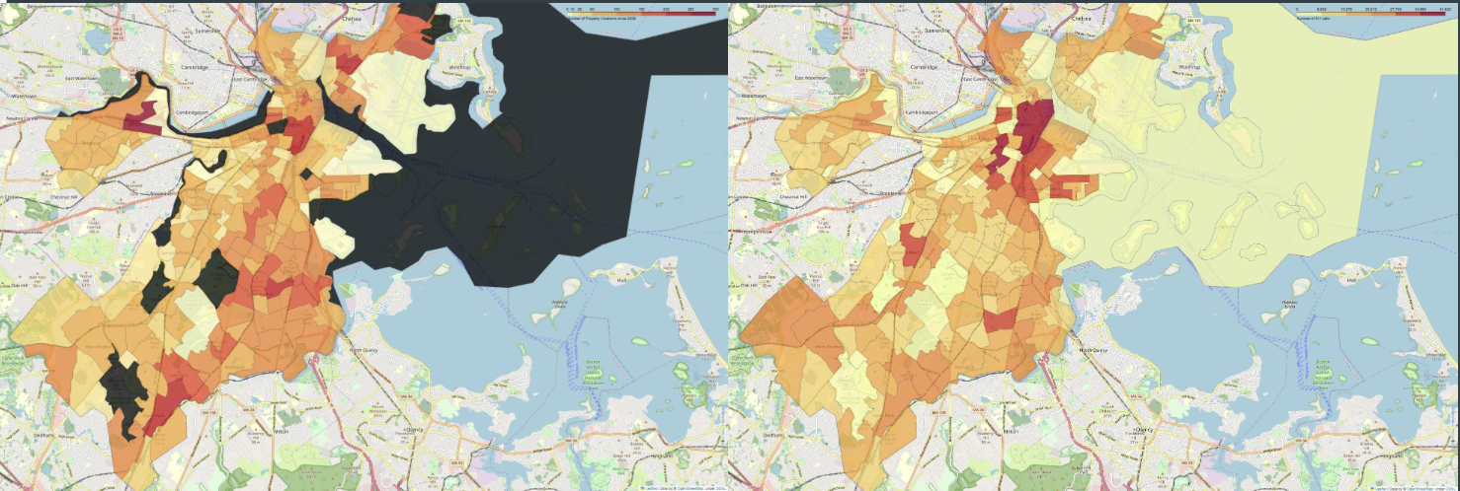

Table 7: Heat map of property violations(left) and heat map of 311 calls per area(right)

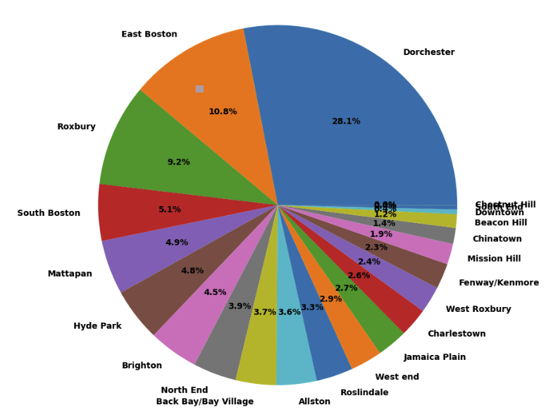

Table 8: Proportion of property violations as a pie chart

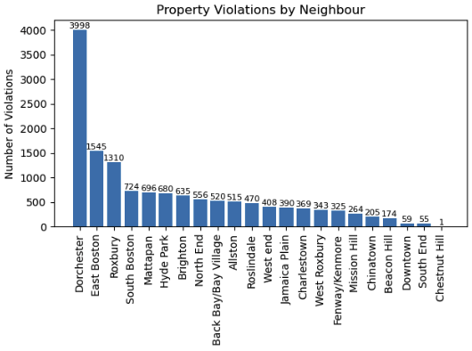

Table 9: Number of violations in a bar chart

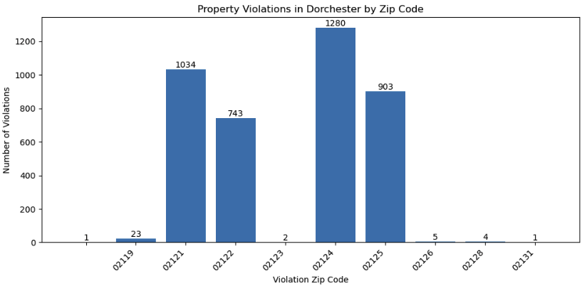

Table 10: Property violations per zip code

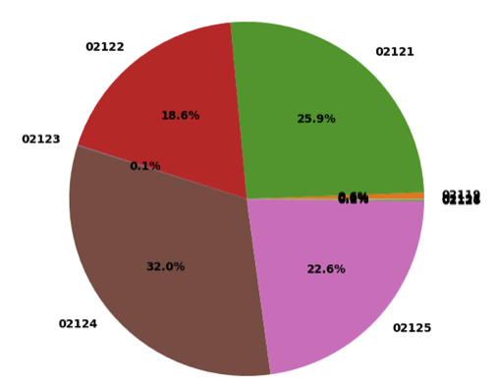

Table 11: Most common zip codes with their property violations.

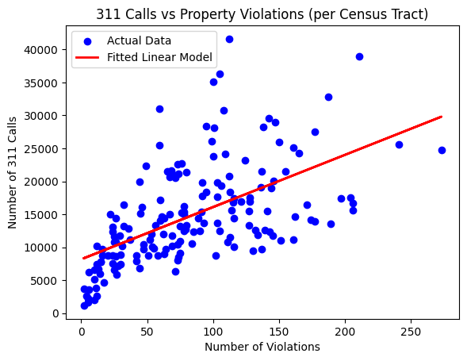

Table 12: Fitted line of number of 311 calls versus the number of violations per census tract

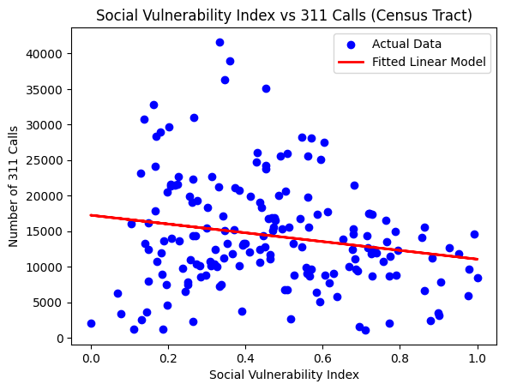

Table 13: Fitted line of number of 311 calls versus SV Index per census tract